DEVELOPMENT OF INFORMATION DISSEMINATION PLATFORM BY INTEGRATING WEB AND ANDROID TECHNOLOGIES

S. Butt, M. Anjum, M. Rehman
Department of Computer Science Lahore College for Women University, Lahore, Pakistan.
maria.anjum@gmail.com

ABSTRACT: The process of accessing admission information from different universities is very tedious for prospective applicants due to time and geographical constraints. Applicants living in distant cities, villages and towns find it hard to receive timely information about admissions and endure transport problems while visiting universities in Pakistan. To address this issue, an efficient and reliable system is required that could provide up-to-date information to prospective students at their own locations. Therefore, in this research, an integrated admission news system using Android and Web technologies has been proposed. A multi-method technique is employed by combining surveys with experiment. A pre-experiment survey is conducted with the university students for need analysis and also to generate themes for the designed application. The post-experiment survey is employed to evaluate the usability of the developed application. By using both technologies, the proposed platform complements the limitation of individual technology and help users having access to these technologies. The post-experiment survey responses shows that more than 80% users found system effective, efficient, easy to use and memorize. Since, responses are collected from undergraduate and graduate students. Therefore, the proposed system could be considered a facilitating platform for prospective students seeking admissions in universities.

Keywords: Content Management System, Mobile Widget, Android, Web Application, Admission Information Delivery

INTRODUCTION
Information systems are important to facilitate users in timely access to up-to-date information in various fields of life that include and not limited to e-health [1], e-agriculture [2], e-learning [3], and social media [4]. The information systems are critical in the environment where resources are limited and long distances are involved to reach to particular information centre [5]. This situation is very common in developing countries and Pakistan is also no exception.
According to [6] apart from well-developed cities such as Karachi, Lahore, Peshawar, and Quetta, the availability of resources is quite limited in small cities, towns and remote areas of Pakistan. To facilitate the population living in these areas, there is a need to develop information system that can provide timely and updated information about events, incidents, health care, disasters and education [7].
At the time of university admissions, information is disseminated through various sources that include newspapers, university websites and social networking sites. However, information provided through these sources has a number of limitations. Firstly, information is not updated in time, secondly information is incomplete in rare cases information about complete admission procedure is available, and thirdly internet facility is not accessible to everyone [7]. Newspapers have become the most accessible source however, only key admission dates are advertised which are not sufficient for prospective students to make decisions. Since public and private universities are located in developed cities therefore, prospective students have to travel to these studies to access relevant information.
This research is conducted to facilitate prospective students who are facing difficulties in receiving admission information due to geographical constraints and limited internet facilities. The research has proposed integrated news platform named as NewzNinja to keeps track of admission information of various universities of Lahore. The system
is available online and on android platform to provide information about admission dates, required documents, office timings, admission criteria and university’s geographical location. The web service in the form of Rich Site Summary RSS feed being used to update data from NewzNinja web application to mobile. NewzNinja aims to minimize the time and difficulty faced by prospective students in accessing admission information of the institute of their choice. The areas where internet facilities are limited, mobile application has the ability to retain information. Therefore, users can access all necessary information offline without worrying about internet facility.

MATERIALS AND METHODS
The multi-method research strategy was adopted by combining observational and experimental research methods, with the aim that the quality of the diverse techniques supplemented one another and provided rigorous results. The research process designed is shown in Figure 1. At first, relevant literature was collected from well-known digital databases that included Institute of Electrical and Electronics Engineers IEEE, Association for Computing Machinery ACM and Science Direct. In the next step, a survey was conducted in five universities of Lahore which is second largest and developed city of Pakistan.
The selection of university and participants were made by employing convenience sampling. The universities included for survey were Lahore College for Women University LCWU, National University of Computer and Emerging Sciences FAST-NU, Punjab University PU, University of Engineering and Technology UET and Institute of Information Technology CIIT also known as COMSATS to identify issues faced by students during admission process. The time period to conduct survey was selected carefully to include participants who were seeking admission in the selected universities and were going
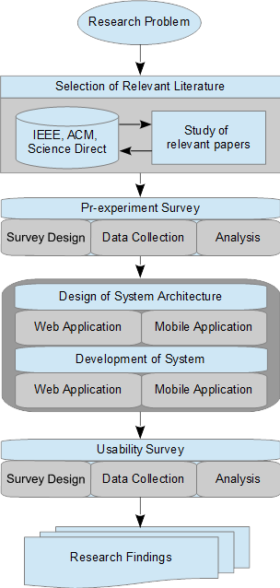
Figure 1: Research Design
through admission process. The findings of this survey were used to design system architecture for both web and mobile applications. Prototypes of applications were presented to the students of selected universities and their responses were collected after they performed various tasks in both the applications. Both applications were developed by employing the latest technologies. The developed applications were evaluated by conducting usability survey. A five point Likert scale was used to record users’ agreement against usability attributes which included effectiveness, efficiency, ease of use, learnability, and memorability of the system.
The stratified random sampling method was adopted to collect data from the students of the selected universities, who wanted to share their admission procedure experience in the current institute and were willing to provide their responses on the existing admission information system. The pre and post experimental survey was carried out through mailed surveys which was extremely efficient in providing information in a relatively brief time period with low cost to researchers.
The pre-experimental survey addressed two purposes. The first purpose was to examine the perception and need requirements of selected samples regarding the improvement and flaws of the existing admission system deployed in the universities. The second purpose was to collect data from students regarding their preferred way of receiving admission information besides the current way of receiving information by visiting university campuses.
The post-experimental survey was to verify that the developed system had fulfilled user needs. The pre-experiment survey instrument was divided into three sections. In the first section, demographic information was collected. In the second section, questions were asked about mobile and web technologies as a tool to provide information at to What were the problems faced by students while taking admission in universities. What were the lacking features in the existing system that could be provided through technology. Also would an integrated solution of mobile and web technologies like the one proposed in this research be a better option.
A total of 31 responses were collected from pre-experimental survey. The respondents were largely between the age group of 17-20 years. In terms of gender, 42% respondents were males and 58% were females. The qualification of respondents largely fell under the category of under-graduates.
In the survey, it was asked to explain all possible ways adopted by respondents, while taking admission in their degree programs. 39.3% of the participants used websites to get information about the admission criteria; 28.6% preferred to visit university campus; 28.6% of the participants consulted newspapers; 3.6% used mobile applications and 60.7% respondents had to ask around from their friends or relatives.
The statistical data revealed that in terms of technology use, 39.3% consulted websites, and rest relied on words of mouth, and manual system. A very little percentage used mobile to access information because there was no such mobile application available. In an answer to a question was that 60% people agreed that they needed a mobile application for getting admission updates while 40% said they need a website for the same purpose.
When asked which device and type of mobile they used, 22% reported simple mobile, 35% used smart phones and rest had laptop or desktop PC facility. From these results it was evident that a use of a combination of technology would be a better solution to accommodate users of smart phones, and computer systems. Therefore, we adopted an integrated solution to facilitate both types of users. Also, mobile users were largely using android technology, therefore in our application we focused on the same technology.
The respondents were further asked to share their experiences of taking admission in the universities of other cities. The responses collected from these questions helped to identify features for the proposed application. One respondent shared experience as “The first and most hectic step is to track down the admissions schedule of all favored universities.” Another respondent said “After getting admission dates, it’s a vicious cycle of paying multiple visits to every campus, first to receive forms, then gather required documents, a slight mistake can cause lot of rework and more visits, and then going to submit them and give the entry test if applicable.”
The problems highlighted by respondents regarding admission system in pre-experiment survey are listed below.
- The information about admission process provided on university websites or by the administration office was incomplete or unclear that caused prospective students to make mistakes in their admission forms.
- Due to incomplete information of admission process prospective students had to travel back and forth between cities to have their documents completed and submitted.
- Had to wait in long queues in universities days leading to the admission deadline. This caused prospective students to stay away from home town for days and to pay additional expenses for accommodation.
It was asked what type of information they would like to receive if admission information was provided through websites and mobile application. The applicants responded by providing their suggestions such as the application should be easily accessible, information should be provided about opening and closing dates, criteria to get admission, office timings, university map and routes, degree programs, university achievements and ranking, merits lists, entry test information, and online submission of admission form and fee submission.
From pre-experiment survey, following features were identified to develop an integrated platform discussed in this research to serve the needs of prospective students.
- To ensure availability of university admission information on website and mobile application.
- Availability of University route map on both applications.
- List of documents needed for admission and office timings.
- Official website links and information from newspaper. This need was not identified from the survey however, we incorporated this feature to increase the reliability of the information provided through our proposed platform.

RESULTS AND DISCUSSION
A pre-experiment survey was conducted with students enrolled in five different the universities of Lahore, to identify the problems they face while taking admission in the universities. The key findings of the survey highlighteded two major issues described below.
- Delayed information about opening and closing dates of admission in different universities made students either to enroll in an institution which was not their first preference or failed to secure admission at all.
- The admission process varied in different universities and it was hard to acquire details about the whole procedure. Since the applicants belonged to various regions in Pakistan therefore, they were not well aware of the location of the university and the city itself. They found it difficult to locate universities which were spread across the city including transportation system. Further, these visits to universities caused additional financial load which included not only traveling but also staying in the city until the procedure was completed.
By considering these concerns, the research aimed to facilitate prospective students in receiving accurate and timely university admission information through an integrated platform consisting of web and mobile applications. The platform was named as NewzNinja whose web application is available online at www.newzninja.com. The platform architecture is shown in Figure 2.
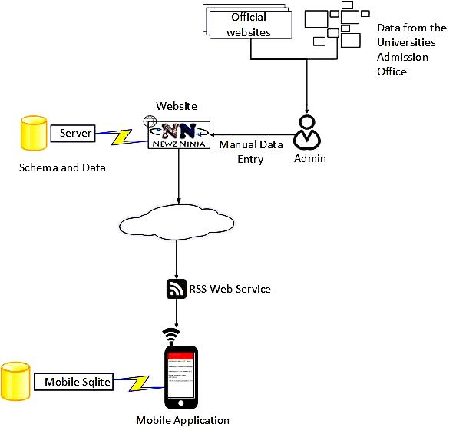
Figure 2: NewzNinja Platform Architecture
The data was updated at NewzNinja server where application schema was available. The information stored in database at server side was displayed on the web interface by connecting MYSQL database with website.
The information available on the website was also made available on the android widget application. For this, RSS feed was used to send data to mobile application. XML web service was parsed to extract news from the website. A method was implemented that referenced the website, created local view, parsed the fetched news into titles through .getName(). The following code was executed in mobile application as an asynchronous task (XML pull parser) and it is initiated to receive the RSS feed.
public void onCreate(Bundle savedInstanceState) {
super.onCreate(savedInstanceState);
// Set view
setContentView(R.layout.main);
// Set reference to this activity
local = this;
GetRSSDataTask task = new GetRSSDataTask();
// Start download RSS task
task.execute("http://newzninja.com/feed/");
// Debug the thread name
Log.d("NewzninjaRssReader", Thread.currentThread().getName());
}
A click listener was created to take the user to the official source of the news.
The purpose of creating a link between news on mobile view and an official source was to create feeling of satisfaction in the users that they were accessing correct and updated news. The benefit of using RSS feed was that same information was available on website and mobile application. This reduced the chances of inconsistencies in both applications.
The system also provided the facility of map to locate university campuses. The map was connected through Google API v2. In mobile application, data was stored in mobile local database using SQLLite database tool. A similar approach was used where news were collected from different news portals and made available to the end user devices [8].
In a study by [9] employed RSS feed to send courses and lab related announcements to students through mobile devices. Their technique was considered time saving and paper free when survey was conducted to evaluate its usage. The benefit of integrated application was that user could access updated information through applications which were convenient way for the user. Further, mobile application helped user to retain information in the situation when internet facility was not available. The widget application was especially developed by considering under privileged cities where WIFI facility was not available 24/7 hours a day.

Newzninja Website was developed in Wordpress CMS. The website provided features that included information about five universities with their official website links, newspaper advertisements, maps, blogs, and subscription option for users. In Figure 3, the website homepage showed posts in order of latest updates. The menu bar showed links to the different university’s pages and options provided by the website. User could select a university from the drop down menu or select a headline to go to the desired university page.
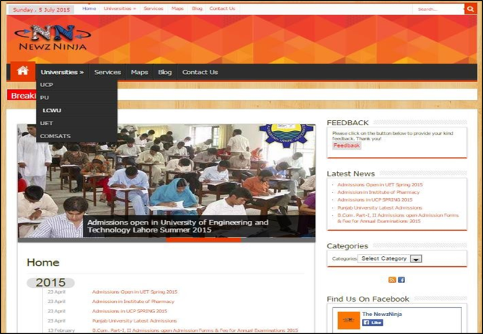
Figure 3: NEWSNINJA Homepage
The university pages showed admission updates and other news related to that university. The user could browse the archives of required university by selecting the headlines on the homepage or selecting the university from the drop down menu. The university map is shown in Figure 4 which provided locations of university campuses in Lahore. The user could enter his location to get shortest distance to the university.
The blog page on the website provided posts on the website with latest one on the top. User could find the latest posted information on the website in this page, without selecting any particular university.
The android application downloads the news feed from website, providing office timings of universities and online documents required for admission purpose. It also provided a map for the universities’ location by using Google APIs. The mobile application interfaces are shown in Figure 5 and Figure 6. In Figure 5, news updates are shown along with the facility to view each university news in a separate tab. In Figure 6 interface settings were provided for the users.
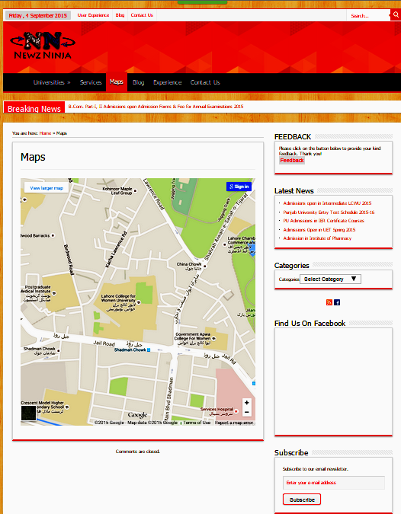
Figure 4: Map to reach desired university

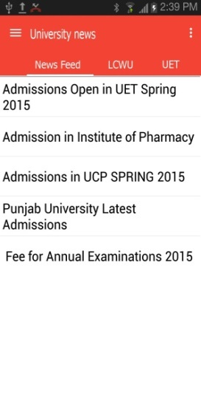 | 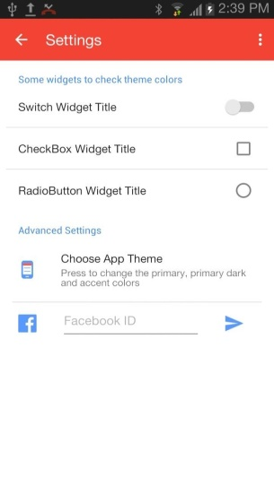
Figure 5: University News UI and Application Settings UI
Further, application provided a list of documents required at the time of admissions. User could switch between the news feed and the documents through the navigation drawer. User can change the theme of the application, checkbox widget title, radio button widget title in setting option. Finally, User can see the location of the university through map.
The purpose of NewzNinja was to manage information of various universities in the city of Lahore and disseminate this information through web and mobile applications. Therefore, proposed platform provided information about admission criteria, required documents, office timings, link to official website and merit of different institutions on a single platform. Google maps integrated in web and mobile applications provided facility to view city map and the map of specific university. The feature of Google Map was not available in any university’s official website.
In the existing studies, we could not find application similar to that discussed in this research. Though various applications were proposed by authors but their purpose and available features were largely specific to one institute. Aydınoğlu [10], developed Geological Information System GIS to provide location of university campuses and departments. Malalha [11], proposed application developed in JSP and mySQL that provided features such as online admission, interviews, form collection and fee submission. In a study [12] developed application in HTML to store records of student academic career, batch number, courses and exam results. Sankaranarayanan and Cox [13], proposed an android based application by using agents. The software agents helped in finding most suitable university by matching user criteria with available university information. Balasaheb et al., [14] developed web based application to facilitate students to take online admission. When compared to these studies, our proposed platform was significantly different in terms of its objectives and the features developed in each application. The platform addressed the needs of users by not only involving two different technologies, but also by providing features that were needed by those living at far. Therefore, one could not find any study in the existing literature that had provided features which could be compared to those available in our platform.
Therefore, to evaluate the usability of proposed platform and identify how far it fulfils user needs, a post-experimental survey was conducted. The developed system was presented to individual users and they were asked to test the usability of the proposed system. On the basis of their experience, they provided their feedback thorough online survey questionnaire.
The survey consisted of six sections. First section was to collect demographic information, and rest of the five sections were designed to address usability attributes associated with the proposed application which included: effectiveness of the system, efficiency of the system, ease with which a software application or product could be picked up and understood by the users, learnability of the system, and memorability of the system.
Table 1
Questions | Avg. | Var. | S. D.
Is it saving your time in order to get admission updates? | 1.32 | 0.47 | 0.68
The web page does not take time in loading? | 1.85 | 1.52 | 1.23
Is it taking time to show updates? | 3.65 | 2.65 | 1.62
The system accommodates different levels of users, from novice to experts? | 1.56 | 0.74 | 0.86
Is it easy for you to navigate through different menu options? | 1.29 | 0.34 | 0.59
Is it easy to go back to the previous page? | 1.24 | 0.25 | 0.50
The symbols, icons and names of the interface are intuitive? | 1.56 | 0.62 | 0.79
The symbols, icons and names of the interface are understandable and meaningful for the context of use? | 1.47 | 0.50 | 0.71
I learned to use the application without any written instruction and help? | 1.26 | 0.32 | 0.57
The used terms, phrases, symbols, and concepts, are written in everyday language? | 1.35 | 0.78 | 0.88
I do not need to recall information from one screen to another? | 1.66 | 1.14 | 1.07
Are the Displays simple? | 1.44 | 1.04 | 1.02
The participants were largely between the age groups of 20-23 years with 78% females and 22% males. 56% responses came from undergraduate students and 44% from graduate students. The survey responses are discussed in Table 1.
Table 1: Usability attributes and respondents’ level of agreement
The responses showed that more than 80% users found system effective, efficient, easy to use and remember. Since, responses were collected from undergraduate and graduate students therefore, our proposed system could be considered facilitating platform for prospective students seeking admissions in universities.

CONCLUSION
The objective of this research was to identify problems faced by students in accessing admission information, proposed a solution by developing and integrated application and evaluate proposed model to verify its usability. The proposed solution provides efficient and reliable way to access information about five different public and private sector universities in Lahore. The integrated platform facilitates users to get online information through website and make this information handy by using mobile application widget. Through this way i.e. non-availability of internet to the users, users will still be able to access relevant information through mobile. In future, more features could be added to both applications such as shortest distance from major transportation places to university campuses and online submission of admission forms. In this case, the proposed platform will be used as intermediary or third party facilitator where universities will be able to post information directly.

REFERENCES
[1] Reinhold H. (2006). Health information systems–past, present, future. International journal of medical informatics 75.3: 268-281.
[2] Ballantyne P., A. Maru, and E. M. Porcari (2010). Information and Communication Technologies—Opportunities to Mobilize Agricultural Science for Development. Crop Science, 50(Supplement_1), S-63.
[3] Welsh E. T., C. R. Wanberg, K. G. Brown, and M. J. Simmering (2003). E‐learning: emerging uses, empirical results and future directions. International Journal of Training and Development, 7(4), 245-258.
[4] Roblyer M. D., M. McDaniel, M. Webb, J. Herman, and J. V. Witty (2010). Findings on Facebook in higher education: A comparison of college faculty and student uses and perceptions of social networking sites. The Internet and higher education, 13(3), 134-140.
[5] Laborda G. J., F. Ozdamli, Y. Maasoglu, and M. Shah (2014), Impact of Management Information Systems (MIS) on School Administration: What the Literature Says, Journal of Procedia - Social and Behavioral Sciences, 5th World Conference on Educational Sciences, Volume 116, 2014, Pages 2799-2804, ISSN 1877-0428.
[6] Kazmi S. W. (2005). Role of education in globalization: A case for Pakistan. SAARC journal of human resource development, 1(1), 90-107.
[7] Mahmood K. (2005). Multipurpose community telecenters for rural development in Pakistan. The Electronic Library, 23(2), 204-220.
[8] Bouras C., V. Poulopoulos, and V. Tsogkas (2010). Adaptation of RSS feeds based on the user profile and on the end device. Journal of Network and Computer Applications, 33(4), 410-421.
[9] Alomari M. H., H. Abusaimeh, S. Shahin, and R. Joudeh (2013). Postat: A Cross-Platform, RSS-Based Advertising and Event Notification System for Educational Institutions. Procedia-Social and Behavioral Sciences, 73, 120-127.
[10] Aydınoğlu A. C., and T. Yomralıoğlu (2002). Web Based Campus Information, System. In International Symposium on GIS, Istanbul, Turkey.
[11] Malalha S. A. (2012). Design And Development of Online Admission System For Alquds Open University in Palestine (Doctoral dissertation, University Utara Malaysia)
[12] Bharamagoudar S. R., R. B. Geeta, and S. G. Totad (2013). Web Based Student Information Management System. International Journal of Advanced Research in Computer and Communication Engineering (IJARCCE), 2(6).
[13] Sankaranarayanan S. and L. Cox (2012). Intelligent Agent based University Search and Admission System- Android Environment. International Journal of Computer Information Systems and Industrial Management Applications, Vol 4, 035-042.
[14] Balasaheb J. S., S. B. Sitaram, W. V. Khushalrao, V. N. Ashok, and P. Bhausaheb (2014). Web Based College Admission System, IJEDR, Vol 3(1), 2321-9939
.

